**Important Questions -**

1. What does the analogy “AI is the new electricity” refer to?

* Similar to electricity starting about 100 years ago, AI is transforming multiple industries. AI is transforming many fields from the car industry to agriculture to supply-chain.

1. Which of these are reasons for Deep Learning recently taking off?

* We have access to a lot more computational power. The development of hardware, perhaps especially GPU computing, has significantly improved deep learning algorithms' performance.
* We have access to a lot more data. The digitalization of our society has played a huge role in this

1. Why iterating over different ML ideas is feasible now a days?

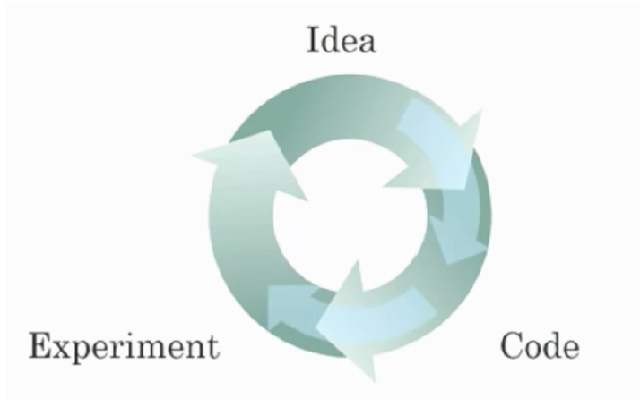

* Being able to try out ideas quickly allows deep learning engineers to iterate more quickly.
* Faster computation can help speed up how long a team takes to iterate to a good idea.
* Recent progress in deep learning algorithms has allowed us to train good models faster (even without changing the CPU/GPU hardware).

1. ReLU activation function?

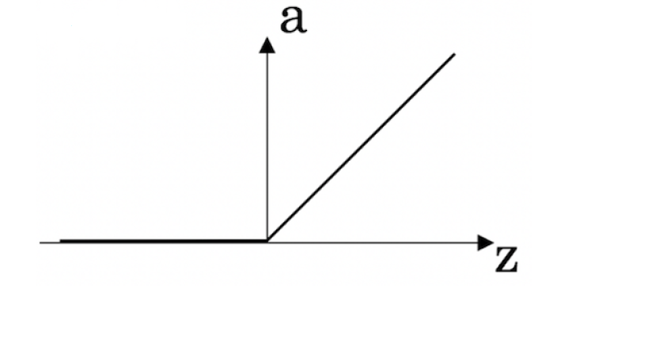

1. Why is an RNN (Recurrent Neural Network) used for machine translation, say translating English to French?

* It can be trained as a supervised learning problem.
* It is applicable when the input/output is a sequence (e.g., a sequence of words). An RNN can map from a sequence of English words to a sequence of French words.

1. Amount of data vs. model size

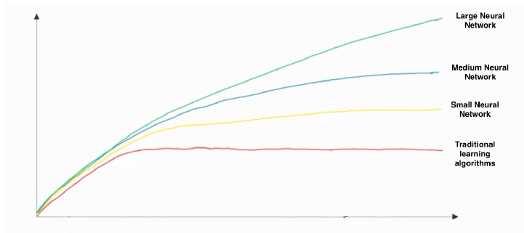

* x-axis is the amount of data
* y-axis (vertical axis) is the performance of the algorithm
* Increasing the training set size generally does not hurt an algorithm’s performance, and it may help significantly.
* Increasing the size of a neural network generally does not hurt an algorithm’s performance, and it may help significantly.

1. What does a neuron compute?

* A neuron computes a linear function (z = Wx + b) followed by an activation function.

1. "Logistic Regression Loss"



1. Suppose img is a (32,32,3) array, representing a 32x32 image with 3 color channels red, green and blue. How do you reshape this into a column vector?

* x = img.reshape((32*32*3,1))

1. Consider the two following random arrays "a" and "b":



What will be the shape of "c"?

* b (column vector) is copied 3 times so that it can be summed to each column of a. Therefore, c.shape = (2, 3)

1. Consider the two following random arrays "a" and "b":



What will be the shape of "c"?

* The computation cannot happen because the sizes don't match. It's going to be "Error"!